2. Implement a basic finite state automaton that recognizes a specific language or pattern. In this example, we&#39;ll create a simple automaton to match strings ending with &#39;ab&#39; using python.
Aim: To implement a finite state automaton that accepts strings ending with ab.
Procedure:
- Read an input string containing a and b.
- Initialize the state.
- Update the state for each character.
- Check the final state.
- Display whether the string is accepted or rejected.
Code:
def check_string(s):
state = 0
for ch in s:
if state == 0:
if ch == 'a':
state = 1
elif state == 1:
if ch == 'a':
state = 1
elif ch == 'b':
state = 2
elif state == 2:
if ch == 'a':
state = 1
elif ch == 'b':
state = 0

if state == 2:
print("Accepted")
else:
print("Rejected")
check_string("abab")
check_string("aaab")
check_string("abba")
Output:
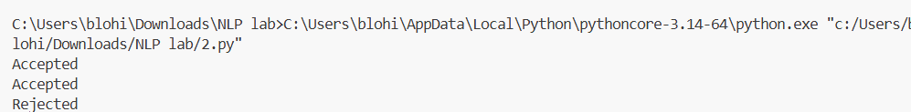
Result: The finite state automaton successfully recognizes strings ending with ab.

